|  |  |
| --- | --- |
| **Digital Forensics**  Diploma in CSF/IT  Year 2/3 (2022/23) Semester 4/6 | Week 12 |
| Practical 10 |
| **Reporting** | |

**OBJECTIVES**

1. To be able to create a well-organized forensic examination report and export it to an appropriate format.

**Overview**

The final phase of a forensic examination is reporting the findings, which should be well organized and presented in a format that the target audience understands.

Case templates in EnCase consist of three parts:

* *Bookmark folders* where references to specific items and notes are stored.
* *Report templates* that hold formatting, layout, and style information. A report template links to bookmark folders to populate content into a report.
* *Case information items*, where you can define case-specific variables to be used throughout the report.

**Part A: Modifying Report Template Formats**

* Report templates are customizable.
* Before viewing a report, you need a report template, or outline of what the report will look like.

Steps:

1. Open Laura.case file in EnCase.
2. To display the template, click Report Templates on the case Home tab.

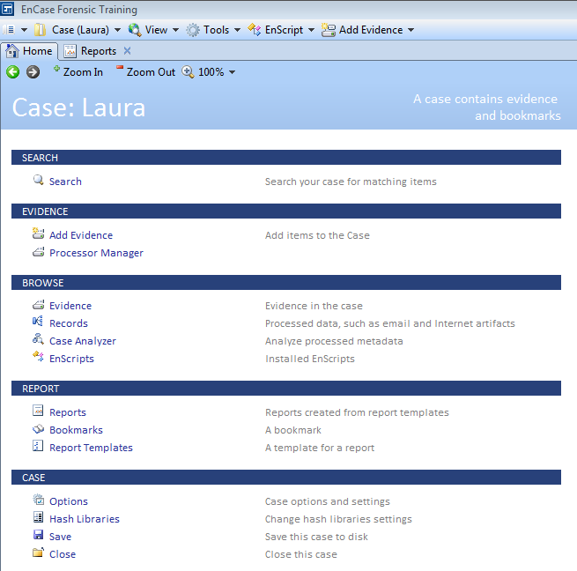

Figure A-1: Case Home Tab

* A report component is designated as either a Report or a Section, as shown in the Type column.
  + Report components contain only formatting information for components beneath them,
  + Section components contain formatting information and Report elements for an individual section.
* The columns to the right of Type indicate whether a formatting option is user defined or inherited from the component above it in the template hierarchy.

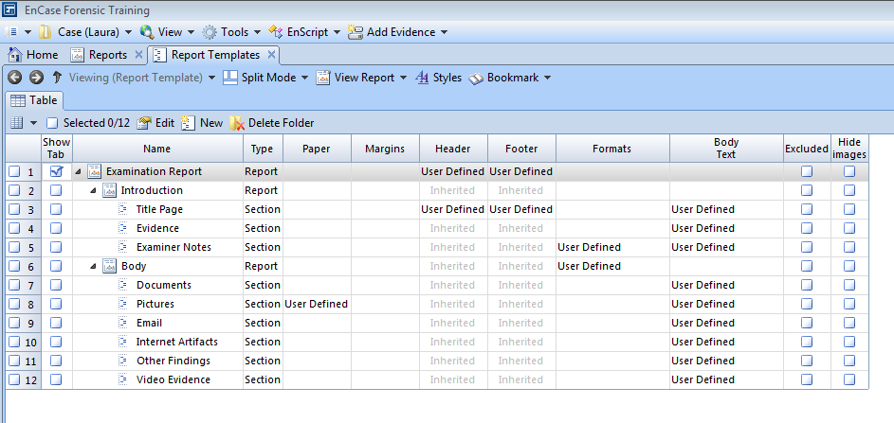

Figure A-2: Report Templates

* We will learn how to add a section to the report template in Part B of the practical.

1. Select Split Mode 🡪 Tree-Table to change to Tree-Table view.
2. To insert a table, right click an item (we will choose Evidence) in the tree where you want to insert a table, then click Edit in the dropdown menu. The Edit dialog opens.

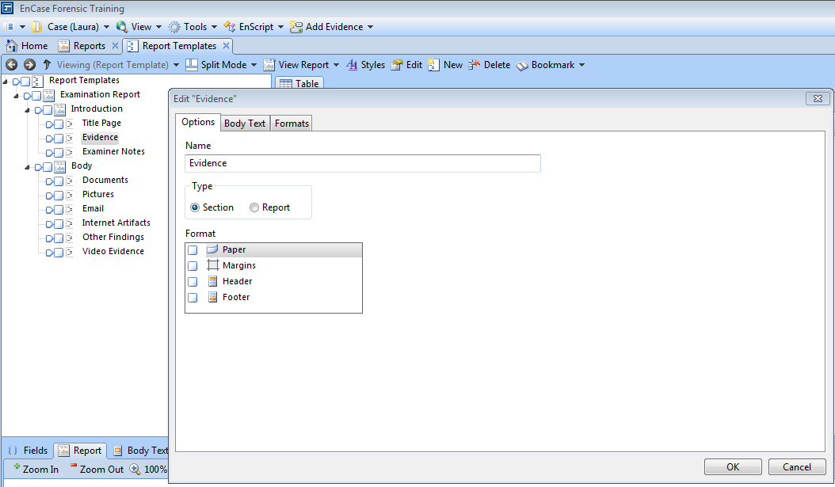

Figure A-3: Edit “Evidence” Dialog

1. Select the Body Text tab, then place your cursor where you want to insert the table into the Report Object Code.
2. Click Add Table 🡪 Evidence.

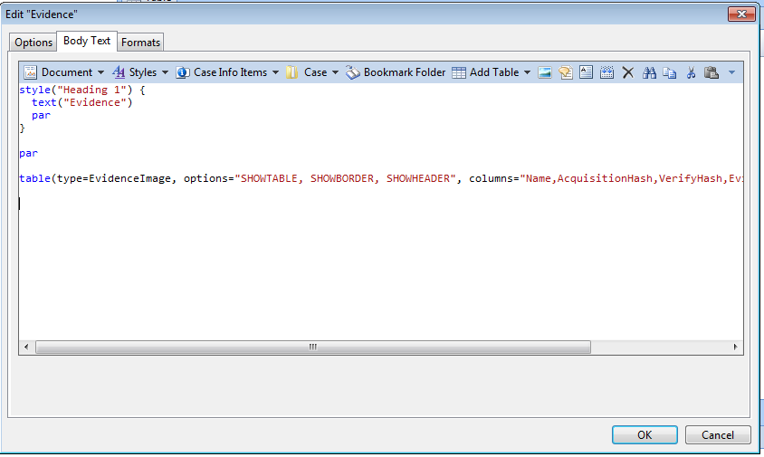

Place cursor here

Figure A-4: Add Table

1. On the Columns tab, click the checkboxes (choose EnCase Version, Serial Number, Model) for the columns you want to display.
2. Ensure there is a line break (shown as parin blue) before and after the newly inserted table.

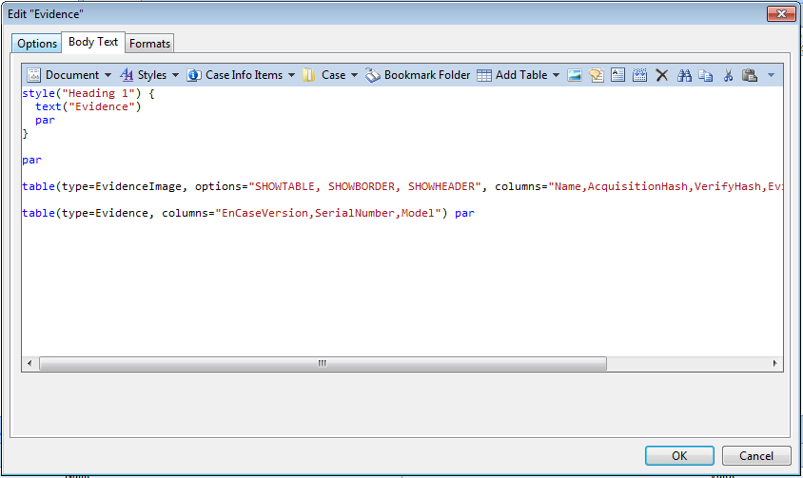

Figure A-5: Body Text

1. Do not select any field in View Options tab.

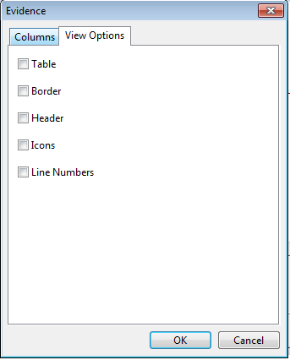

Figure A-6: View Options Tab

1. When you finish, click OK.
2. Preview the report to check if the changes are reflected in the report.

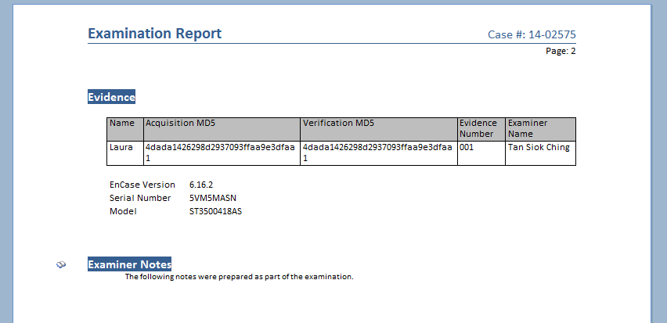

Figure A-7: Previewing Report

1. You may try out other features such as inserting a picture in the Title Page.

**Part B: Exporting the Report**

* In the past practical activities, we have saved data to the Bookmarks tab. This data will be included in our report.
* *You should have added appropriate Notes and comments in the bookmarks to annotate report data and make it easier to identify the bookmarked content. If not, you may do so any time before exporting the report.*
* When Laura case was created, the Basic Template was chosen.
* This template contains six bookmark folders: Examiner Notes, Documents, Pictures, Email, Internet Artifacts, and Other Findings.
* The Report Template includes configuration of the display of the objects in these specific folders within the Report. If you want a bookmarked item to be displayed with this unmodified template, then it must be stored in one of the six listed bookmarked folders.
* We can add a bookmark folder to report template.

Steps:

1. Open Laura.case file in EnCase.
2. Access the Bookmarks tab by clicking on the tab or by selecting View 🡪 Bookmarks.

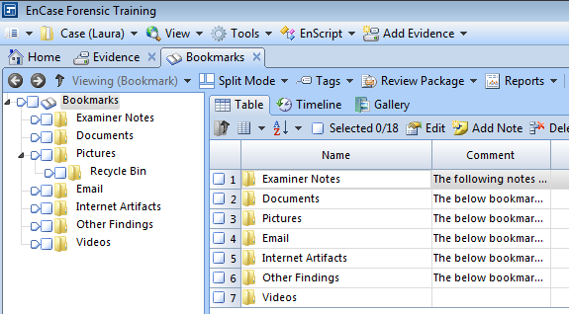

Figure B-1: Bookmark Folders

* You can see that all of our base bookmark folders match up to the folders defined in the report template except one.
* “Videos” is a new folder created by the user and is not defined in the Report Template.
* The subfolder “Recycle Bin” in the Pictures folder will not affect the display of those items. This is because the Pictures folder is set to display items within it and any subfolders. The term is called “recursive”.
* We will cover more about this when adding a bookmark folder to Report template.

1. From Bookmarks, click on the Reports menu 🡪 View Report and Examination Report.

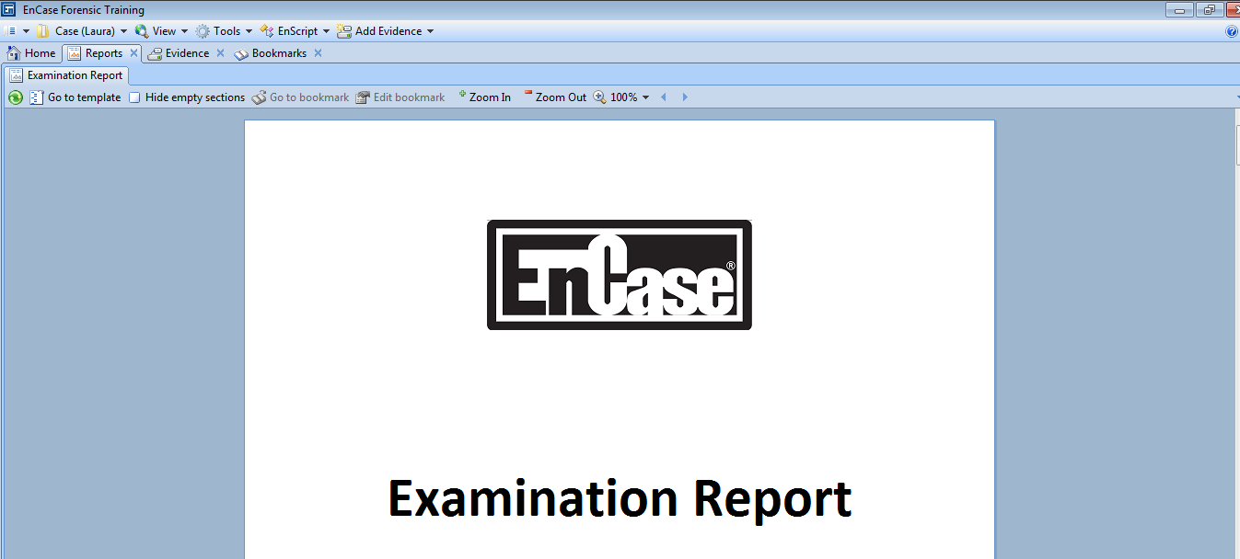

Figure B-2: Viewing the Report

* By reviewing the report we can check to be sure it displays our information as necessary.
* By navigating to the bookmarks, we can delete what is not needed in our report.

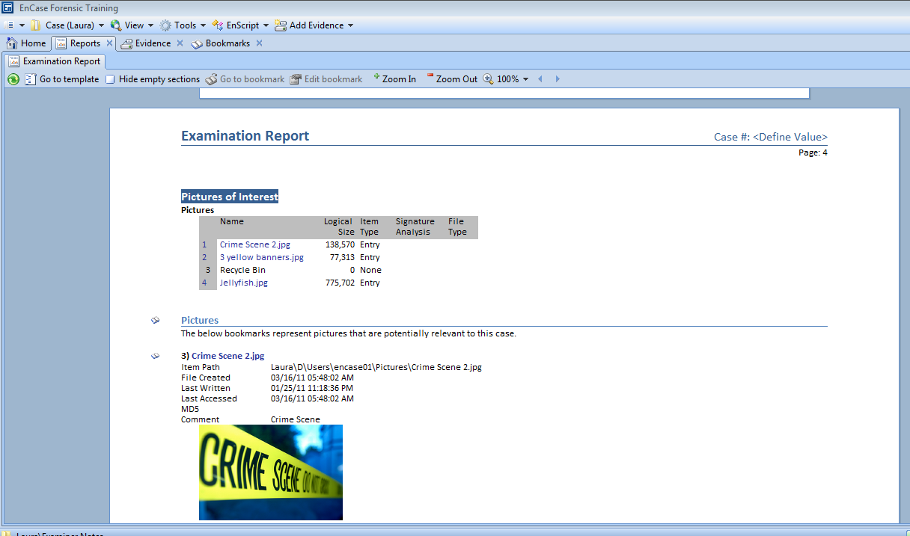

Figure B-3: Reviewing the Report

* By scanning to the bottom of the report, we noticed 2 things. The first is that the Case Number value was not defined, the second is that the Videos bookmark folder is not showing.
* Let’s fix both these issues.

1. Navigate to the case information entry by clicking View 🡪 Case Info Items. From this screen, we can double click on any entry to edit or add information.

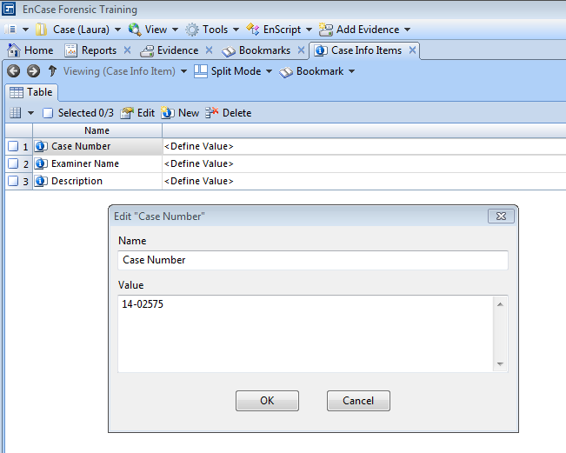

Figure B-4: Case Info Items Entry Screen

1. Once the case information items are entered, let’s go back and view the report by clicking View 🡪 Reports.

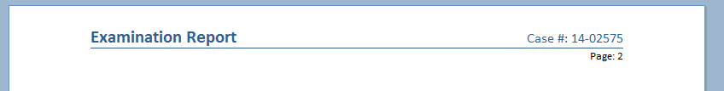

Figure B-5: Case Info Items Displayed in Report

* The case number is displaying correctly within our report.
* Now, let’s move to remedy the issue of the Videos folder not being displayed within the report. We are going to modify the report template to display the bookmark folder you need.

1. By clicking View 🡪 Report Templates, we will see the existing report template. We want to add a section for our Videos folder.

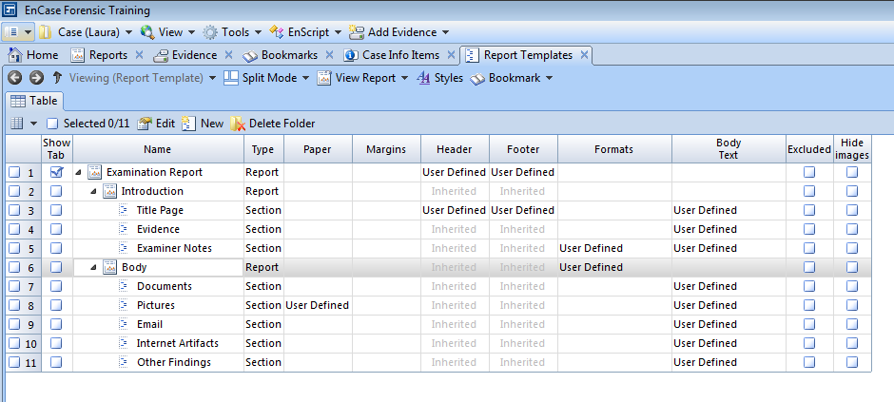

Figure B-6: Report Template

1. Highlight the Body report section and click New.
2. Let’s name the new addition “Video Evidence” and leave it as a Section type. This means it will inherit any attributes by the report above it. Click OK to proceed.

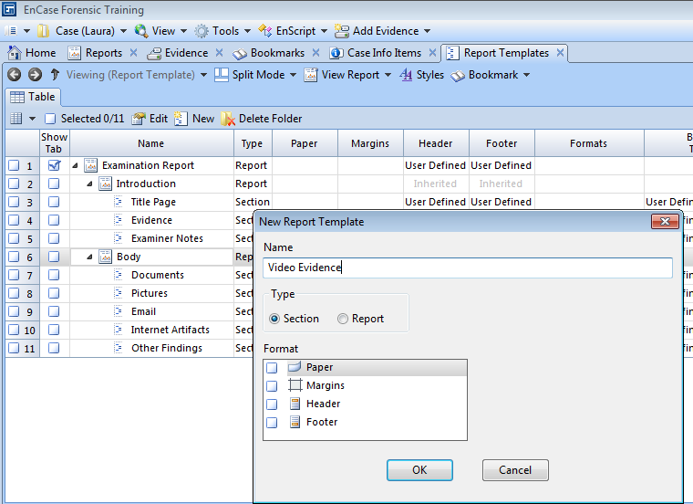

Figure B-7: Adding Report Template Section

1. The new section is now listed under the Body report and underneath Other Findings.

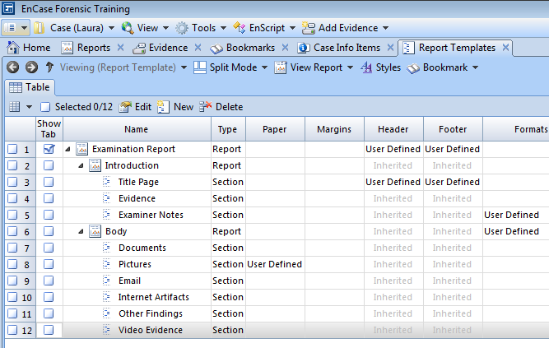

Figure B-8: No Body Text yet defined

* Once the Video Evidence section is highlighted, the View Pane will display nothing under the Body Text tab. If you tried to view it in View 🡪 Reports, nothing will show yet.

1. To add the bookmark folder, click into the Body Text area and select Bookmark Folder. This will bring up an entry screen.
2. On the screen highlight the Videos folder with a click.
3. Click Show Folders and Recursive to show the information from the folder in the bookmarks and contents of any other folders stored under the Videos bookmark folders or any subfolders.
4. Click OK.

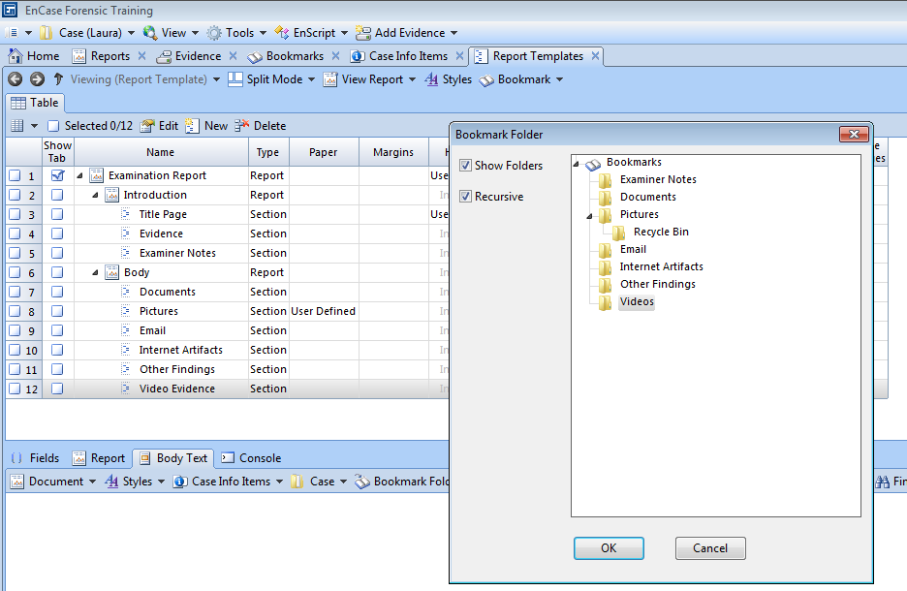

Figure B-9: Adding a Bookmark Folder to the Report Template

1. The Body Text will be added.

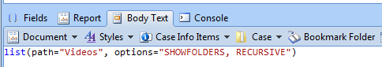

Figure B-10: Body Text added to the Report Template

1. Click View 🡪 Reports and navigate to the bottom of the report. We can see the videos have been added.

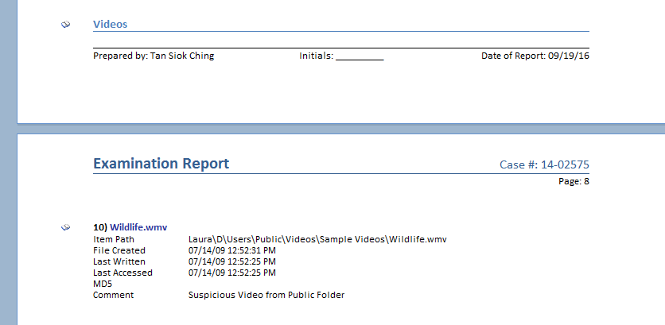

Figure B-11: Videos Bookmark Folder added to Report

1. EnCase allows the report to be saved in many different formats.
2. While you are viewing the report, simply right click and select Save As…. This will bring up the options for saving your report.
3. The report can be saved in TXT, RTF, HTML, XML, and PDF formats. We will start with the RTF format. Take note of the location where the report will be stored after exporting.
4. Click OK.

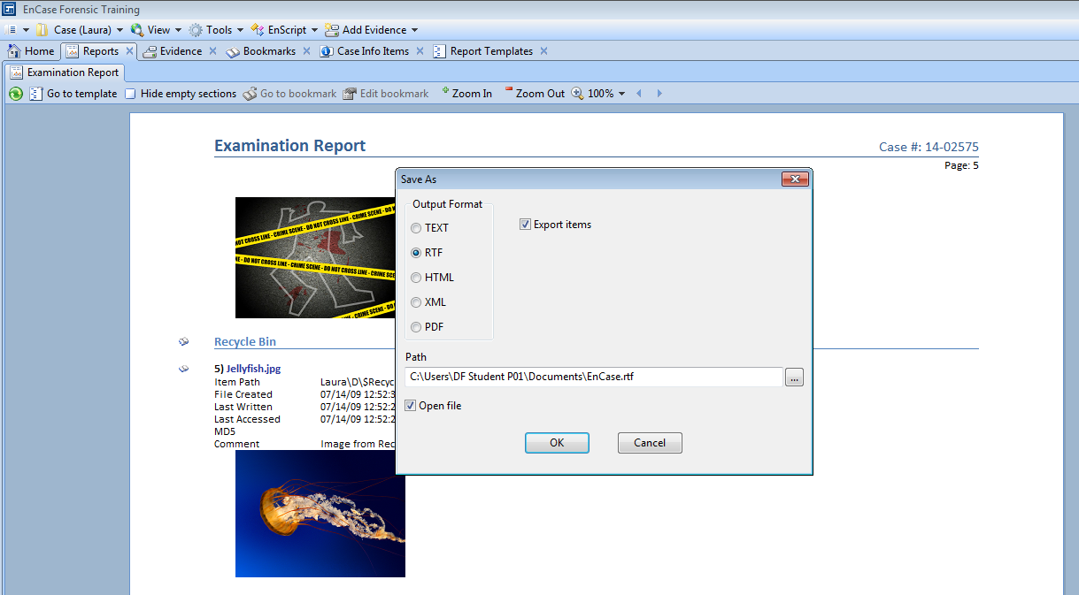

Figure B-12: Report Exporting Options

1. Proceed to export the report in other formats.

Reference

* Guidance Software, Inc, *EnCaseComputer Forensics I* – v7.10pi (06.11.2015).
* Guidance Software, Inc, *EnCaseForensic / EnCaseEnterprise User Guide Version 7.11* (1997)

- The End -